AI ASSISTED LAB ASSIGNMENT – 2.1

Exploring Additional AI Coding Tools beyond Copilot

Name: J.Bhargvavi

Roll_no:2503A52417

Batch_no:14

Task-1: Statistical Summary for Survey Data

Input:

#generate a Python function that reads a list of numbers and calculates the mean, minimum, and maximum values.

def calculate_statistics(numbers):
if not numbers:
return None, None, None # Return None for mean, min, and max if the list is empty

mean_value = sum(numbers) / len(numbers)
min_value = min(numbers)
max_value = max(numbers)

return mean_value, min_value, max_value
#exapmple usage:
numbers = [10, 20, 30, 40, 50]
mean, minimum, maximum = calculate_statistics(numbers)
print(f"Mean: {mean}, Minimum: {minimum}, Maximum: {maximum}")

Explanation:
The calculate _ statistics () function efficiently calculates the mean, minimum, and maximum of a list of numbers. It first checks whether the list is empty to avoid errors. Then it uses sum() and len() to calculate the mean and the built-in min() and max() functions to find the smallest and largest values.

Output:
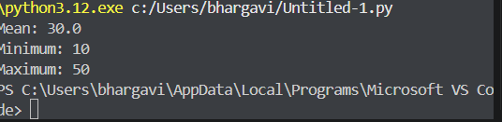

Task-2: Armstrong Number – AI Comparison

Input:

#Generate an Armstrong number checker using Given a number, check if it is an Armstrong number or not. Compare their outputs, logic style, and clarity.
def is_armstrong_number(n):
# Convert the number to a string to easily iterate over each digit
digits = str(n)
num_digits = len(digits)

# Calculate the sum of each digit raised to the power of the number of digits
armstrong_sum = sum(int(digit) ** num_digits for digit in digits)

# Check if the calculated sum is equal to the original number
return armstrong_sum == n
# Example usage:
number = 153
if is_armstrong_number(number):
print(f"{number} is an Armstrong number.")
else:
print(f"{number} is not an Armstrong number.")

Explanation:
An Armstrong number is a number in which the sum of each digit raised to the power of the number of digits is equal to the original number.

Output:
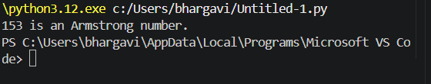

Task-3: Leap Year Validation Using Cursor AI

Input:
#generate a Python program that checks whether a given year is a leap year.also give two different methods to check for leap year and compare their outputs, logic style, and clarity.
def is_leap_year_method1(year):
if (year % 4 == 0 and year % 100 != 0) or (year % 400 == 0):
return True
else:
return False
# Example usage:
year = 2020
if is_leap_year_method1(year):
print(f"{year} is a leap year.")
else:
print(f"{year} is not a leap year.")

# Method 2: Using a more concise approach
def is_leap_year_method2(year):
return year % 4 == 0 and (year % 100 != 0 or year % 400 == 0)
# Example usage:
year = 2021
if is_leap_year_method2(year):
print(f"{year} is a leap year.")
else:
print(f"{year} is not a leap year.")

#example usage:
year = 2024
if is_leap_year_method1(year) == is_leap_year_method2(year):
print(f"Both methods agree that {year} is a leap year: {is_leap_year_method1(year)}")

Explanation:
A leap year is a year that contains 366 days instead of 365. In Python, we can check whether a year is a leap year using divisibility rules. A year is a leap year if it is divisible by 4, but century years must also be divisible by 400. The program uses two methods to perform this check. The first method uses an if-else statement, while the second method uses a shorter Boolean expression. Both methods produce the same output. Method 1 is easier for beginners to understand, while Method 2 is more concise and clear for experienced programmers.

Output:
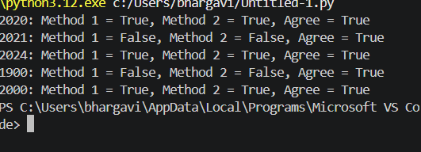

Task-4: Student Logic + AI Refactoring (Odd/Even Sum)

Input:

#Write a Python program that calculates the sum of odd and even numbers in a tuple.

#Write a Python program that calculates the sum of odd and even numbers in a tuple,

def sum_odd_even(numbers):

odd_sum = sum(x for x in numbers if x % 2 != 0)

even_sum = sum(x for x in numbers if x % 2 == 0)

return odd_sum, even_sum

# Example usage:

tuple_numbers = (1, 2, 3, 4, 5, 6, 7, 8, 9, 10)

odd_total, even_total = sum_odd_even(tuple_numbers)

print(f"Sum of odd numbers: {odd_total}")

print(f"Sum of even numbers: {even_total}")

Explanation:
This Python program calculates the sum of odd and even numbers in a tuple. The function checks each number using the modulus (%) operator. If the remainder after division by 2 is not zero, the number is odd; otherwise, it is even. The sum() function adds the numbers separately. Finally, the program displays the total of odd numbers as 25 and even numbers as 30.

Output:



